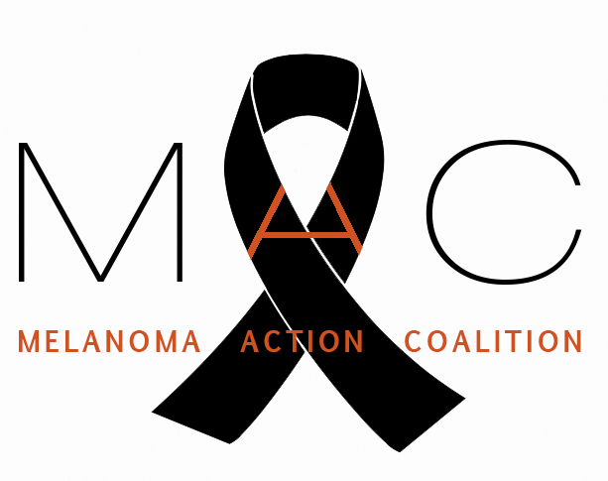

MELANOMA ACTION COALITION

March --, 2021

Janet Woodcock, M.D. Acting Commissioner
Food and Drug Administration
U.S. Department of Health and Human Services
10903 New Hampshire Avenue
Silver Spring, MD 20993

RE: Finalization of Sunlamp Rule and Amendment to Performance Standard

Dear Acting Commissioner Woodcock:

The Melanoma Action Coalition (MAC) respectfully requests that the Food and Drug Administration, working with the Department of Health and Human Services, finalize the proposed rules entitled General and Plastic Surgery Devices: Restricted Sale, Distribution,
and Use of Sunlamp Products (Docket No. FDA-2015-N-1765); and the Sunlamp Products; Proposed Amendment to Performance Standard (Docket No. FDA-1998-N-0880) published by the FDA in the Federal Register on December 22, 2015 (80 Fed. Reg. 79493 and 80 Fed. Reg. 79505 et seq.)

The Melanoma Action Coalition represents more than 40 community-based foundations and advocates nationwide focused on increasing awareness about melanoma, providing education about sun safety, and raising funds for melanoma research. Each of us has been touched personally by melanoma. Some of us are survivors; others have lost spouses or children to this disease. We are united by our dedication to working towards a time when no other individuals or families suffer the pain and loss that we have experienced.

Melanoma is the fifth most common cancer in the United States. While the incidence of many other cancers has decreased in recent years, the incidence of melanoma has been rising. Although it strikes all age groups, melanoma disproportionately affects young people. It is the second most common cancer in men and women ages 15 to 29. Melanoma is expected to strike more than 106,000 Americans this year in all and to kill more than 7,000. While it is curable in its early stages and while research is making great progress in prolonging the lives of those with advanced melanoma, patients diagnosed with Stage IV metastatic melanoma have a median survival of less than one year after diagnosis.

Exposure to ultraviolet (UV) radiation is among the greatest risk factors in melanoma, and the one that can most easily be controlled. In addition to limiting sun exposure, eliminating the use of UV tanning devices promises to be the most effective means we have to reduce the incidence of melanoma. The evidence linking the use of UV tanning devices to melanoma and other skin cancers has been well documented in the scientific
literature and is reviewed in the FDA docket. UV-emitting sunlamp products are carcinogenic to humans and a known health danger as recognized by leading health authorities, including the World Health Organization, US Centers for Disease Control and Prevention, and US Department of Health and Human Services.

We commend the FDA for issuing the proposed rule prohibiting minors under age 18 throughout the U.S. from using tanning beds and requiring that adult tanning bed users be informed about the serious health risks of indoor tanning—including the increased risk of developing potentially fatal melanoma and other skin cancers—through a risk acknowledgement certification, and for strengthening sunlamp performance standards. We urge the FDA to expeditiously finalize these rules.

Given the pressing need to fight melanoma and other skin cancers, and the fact that the use of sunlamp products is an entirely avoidable risk factor, we support the FDA’s actions to change the regulation of sunlamp products in a way that recognizes their clear hazard to public health. Finalizing the two proposed sunlamp rules will have a significant impact in reducing the incidence of skin cancer, including melanoma, in the United States. We urge you to act quickly to put these rules into place.

We thank you for your leadership in this matter. Should you have any questions, please contact me at (609) 230-5698, nspiegler@aol.com.

Sincerely,

Neil Spiegler
President
Melanoma Action Coalition

Endorsing members:
Miggy’s Gift
The Peggy Spiegler Melanoma Research Foundation
Skin of Steel
The White Aisle Foundation

