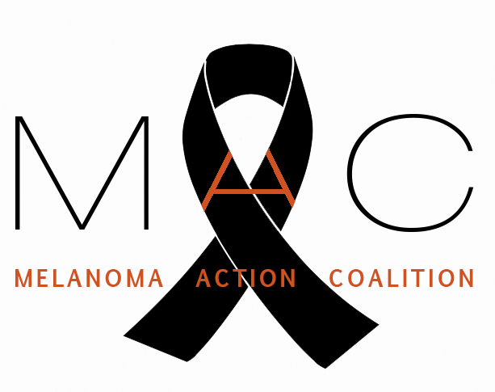

MELANOMA ACTION COALITION

January 27, 2016

Food and Drug Administration
5630 Fishers Lane, Room 1061
Rockville, MD 20852
Submitted via www.regulations.gov

RE: Docket No. FDA-2015-N-1765

To Whom It May Concern:

On behalf of the Melanoma Action Coalition (MAC), thank you for the opportunity to provide comments in response to the proposed rule “General and Plastic Surgery Devices: Restricted Sale, Distribution, and Use of Sunlamp Products” (Docket No. FDA-2015-N-1765) published in the Federal Register on December 22, 2015. MAC supports the proposed rule and applauds the Food and Drug Administration (FDA) for taking this step to protect the public from the dangers of tanning devices.

The Melanoma Action Coalition represents 14 community-based foundations nationwide focused on increasing awareness about melanoma, providing education about sun safety, and raising money for melanoma research. Each of us has been touched personally by melanoma. Some of us are survivors; others have lost spouses or children to this disease. We are united by our dedication to working towards a time when no other individuals or families suffer the pain and loss that we have experienced.

Melanoma is the fifth most common cancer in the United States. While the incidence of many other cancers has decreased in recent years, the incidence of melanoma has been rising. Although it strikes all age groups, melanoma disproportionately affects young people. It is the second most common cancer in men and women ages 15 to 29. Melanoma strikes more than 76,000 Americans each year in all and kills more than 9,700. While it is curable in its early stages and while research is making great progress in prolonging the lives of those with advanced melanoma, patients diagnosed with Stage IV metastatic melanoma have a median survival of less than one year after diagnosis.

Exposure to ultraviolet (UV) radiation is among the greatest risk factors in melanoma, and the one that can most easily be controlled. In addition to limiting sun exposure, eliminating the use of tanning devices promises to be the most effective means we have to reduce the incidence of melanoma. The evidence linking the use of UV tanning devices to melanoma and other skin cancers has been well documented in the scientific

literature and is reviewed in the FDA docket. UV-emitting sunlamp products are carcinogenic to humans and a known health danger as recognized by leading health authorities, including the World Health Organization, US Centers for Disease Control and Prevention, and US Department of Health and Human Services.

MAC urges FDA to consider a total ban on the sale and use of indoor tanning equipment for non-medical purposes by both minors and adults. Barring that, this proposed rule will protect the health of children. Young people are particularly susceptible to social pressures that lead to the use of indoor tanning facilities. Moreover, they face a higher risk of developing skin cancer in their lifetime than individuals who begin tanning as adults.

According to a 2012 investigation by the US House of Representatives Committee on Energy and Commerce, the tanning industry has specifically targeted the teen market and provided misleading information about the risks of indoor tanning. Parental permission laws do not offer adequate protection for children under these circumstances. Therefore, MAC supports the FDA’s proposed rule to restrict the sale, distribution and use of sunlamp products, including restricting the use of indoor tanning devices to individuals 18 and older and requiring prospective users to sign a risk acknowledgement certification before use and every six months thereafter. MAC recommends that the risk of skin cancer, including melanoma, be explicitly included in the acknowledgement certification.

We urge the FDA to finalize the proposed rule to restrict the sale, distribution and use of sunlamp products. MAC thanks the FDA for their leadership in protecting the public from these dangerous devices.

Sincerely,

Christine Garrison, Steering Committee Member
on behalf of the Melanoma Action Coalition Steering Committee

