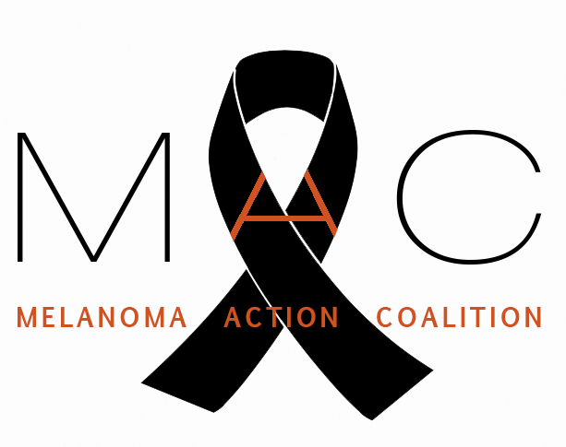

MELANOMA ACTION COALITION

August 29, 2016

Robert M. Califf, M.D., Commissioner
Food and Drug Administration
U.S. Department of Health and Human Services
10903 New Hampshire Avenue
Silver Spring, MD 20993

RE: Finalization of Sunlamp Rules

Dear Commissioner Califf,

The Melanoma Action Coalition (MAC) appreciates the Food and Drug Administration (FDA) soliciting comments on proposed rules: General and Plastic Surgery Devices: Restricted Sale, Distribution, and Use of Sunlamp Products (Docket No. FDA-2015-N-1765); and Sunlamp Products; Proposed Amendment to Performance Standard (Docket No. FDA-1998-N-0880). Sunlamp regulation is a high priority for MAC. The public’s health continues to be at risk from the current state of insufficient sunlamp regulation; therefore, we encourage the FDA’s expeditious finalization of rules restricting minors’ use of sunlamps, requiring risk acknowledgement certification from adults, and strengthening the sunlamp performance standards.

As stated in many comment letters from our members, parental consent is inadequate to protect children and adolescents from the risks of indoor tanning, particularly exposure to ultraviolet (UV) radiation – a known human carcinogen. MAC strongly opposes indoor tanning for anyone, and especially for minors. We support a restriction on the production and sale of indoor tanning equipment. Additionally, educating the public about the health risks of indoor tanning is extremely important to seriously help tackle the epidemic of skin cancer in the U.S. We commend the FDA for issuing the proposed rule prohibiting minors under age 18 throughout the U.S. from using tanning beds and requiring adult tanning bed users be informed about the serious health risks of indoor tanning through a risk acknowledgement certification – including the increased risk of developing potentially fatal melanoma and other skin cancers.

The Melanoma Action Coalition represents 20 community-based foundations nationwide focused on increasing awareness about melanoma, providing education about sun safety, and raising money for melanoma research. Each of us has been touched personally by melanoma. Some of us are survivors; others have lost spouses or children to this disease.

We are united by our dedication to working towards a time when no other individuals or families suffer the pain and loss that we have experienced.

Exposure to ultraviolet (UV) radiation is among the greatest risk factors in melanoma, and the one that can most easily be controlled. In addition to limiting sun exposure, eliminating the use of UV tanning devices promises to be the most effective means we have to reduce the incidence of melanoma. Finalizing the two proposed sunlamp rules will be a significant step in moving us toward that goal, and so we urge you to act quickly to finalize these rules.

We look forward to continuing to collaborate with the FDA in furtherance of protecting the public’s health. Should you have any questions, please contact me at 609) 230-5698, nspiegler@aol.com

Sincerely,

Neil Spiegler,
Steering Committee Chair
Melanoma Action Coalition

